STUDENT Joseph Roper

SALFORD CITY COLLEGE | FUTURE SKILLS

BTEC National Extended Diploma in Creative Media Production

UNIT 72: COMPUTER GAME DESIGN

Unit 72 – Game Design Document

# Brief Intro

In the game you play as a child who was separated from his parents as you are left in a shanty town to survive on your own. The child soon becomes wanted for stealing food from market stalls making you wanted by the guards as you climb and crawl through the map being chased while you try to find your parents. The genre of the game will be a puzzle platformer therefore the game will revolve around solving puzzles to unlock the new areas of the game while traversing over the dangerous in-game architecture. A main aspect of the game is also how you would avoid the guards by finding new with your small stature.

I am aiming the game to be the age rating of 12+ as I believe if the player is younger than 12 they might not understand the story and will struggle too much with the puzzle elements of the game. To back up my decision I looked at the age rating for the game LIMBO and that was 12+ as well helping me make a decision as my game will be inspired by LIMBO

# IP Discussion

This game will be an original IP as the idea for the game is my own and doesn’t copy another games story. The genre may be similar to other games like Inside and Little Nightmares however the game will not oppose on copyright.

# Terrain/Architecture

The game will be held in a shanty town meaning the terrain will be sand, dirt and old scrap buildings which the player will have to go across. The buildings will be made out of scrap metal, bricks, wood and plastic and will break easily if the player stays on them for too long or jumps on them several times. There will be occasional be rusty metal pipes that the player can damage themselves on.

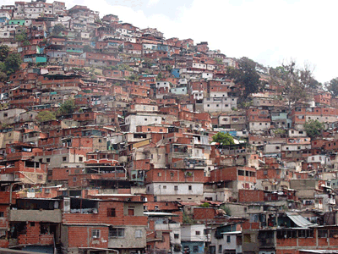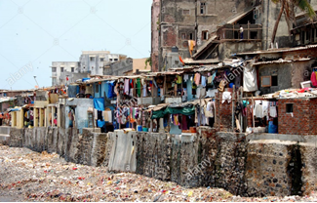

There will also be a section in the game where the player will travel to a city with tall skyscrapers parks and a white brick church.

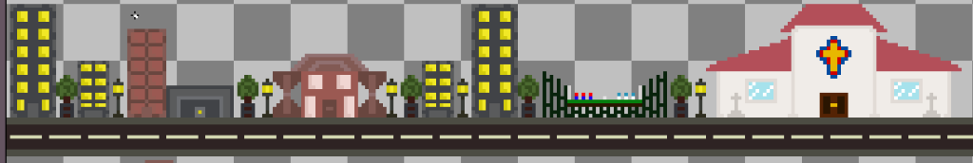

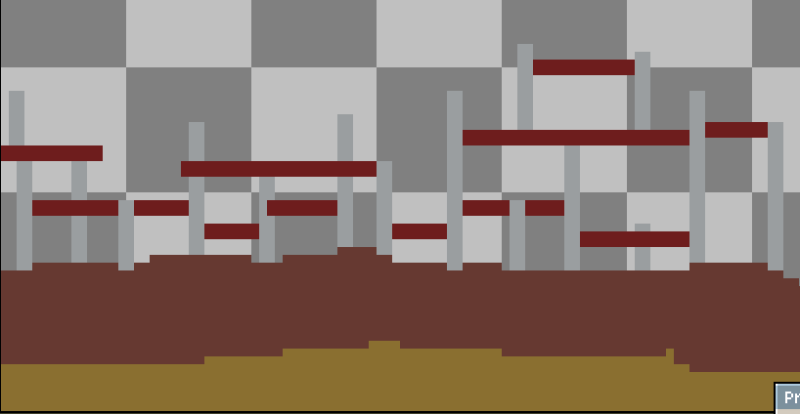

# Objects

Usable objects I will have in my game are rocks and sticks that the player will be able to pick up and throw at structures to open up new paths in the game for the player to explore. Other objects will be crates that the player will be able to move to access unreachable areas. One more object that will be in the game is a sword or more specifically a scimitar which is an exotic weapon which will be held by the guards.

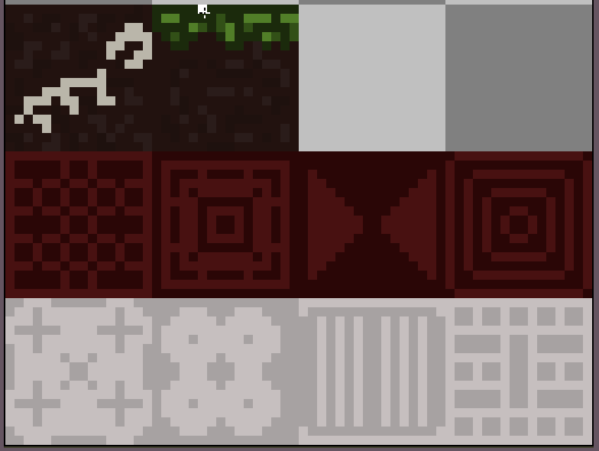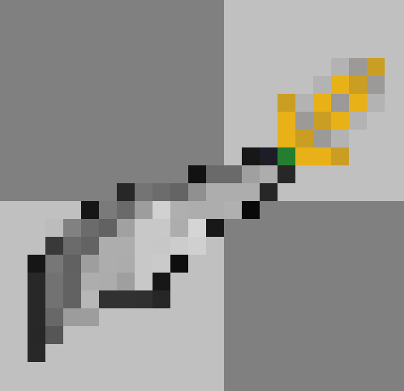

# Character

The only playable character is the main character who is a young child lost and looking for his parents and his friend the crab.

Character’s Name: Mvulana

Character Type: Protagonist

Character Backstory: He is 12 years old and has parents, he used to have a little sister who was stoned to death for committing a crime no one knows. Mvulana has been haunted by his sister’s death and because of this he trusts no one apart from his parents.

Capabilities: Mvulana is quick, nimble and also small meaning he can fit through small holes and cracks.

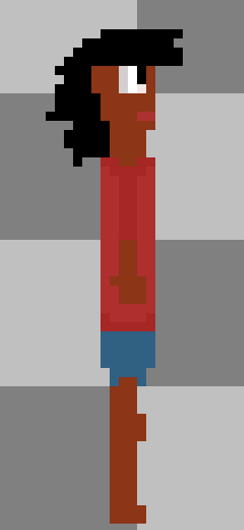 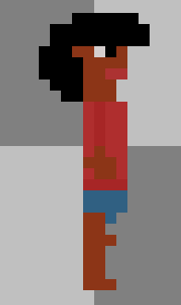

# NPC’s

The main NPC in the game is the main protagonist for the player the head guard.

NPC Name: Head Guard

NPC Type: Antagonist

NPC Backstory: He is the head guard of the police force from the big city and is currently working in the slums to stop violence that is why he stopped the shop keeper from attacking Mvulana. He also is old friends with Mvulana’s parents and that is why he took Mvulana to the station to reunite him with his parents.

Capabilities: Is big and strong and has a sword on him.

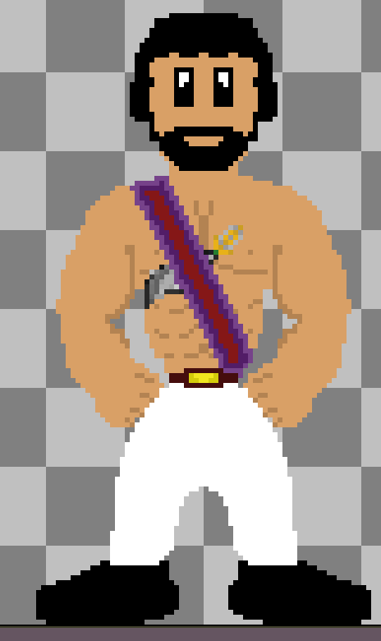 

# Feedback

The feedback the player will receive for the platformer game will be through sound, touch and sight. With sound, the player will be able to hear when enemies are close giving the player a chance to avoid them. With touch, the controller will vibrate when the player gets hit or falls from a ledge representing damage. And finally, though sight the player will be able to see the players health bar and read dialogue when speaking with NPC’s.

# Interface

The interface for the platformer will be left quite simple with the players health and money in the top left corner of the screen. I went with this as I believe it is all the information the player needs to know. I also chose the interface to be quite simple as I know it is achievable with the game engine I will be using.

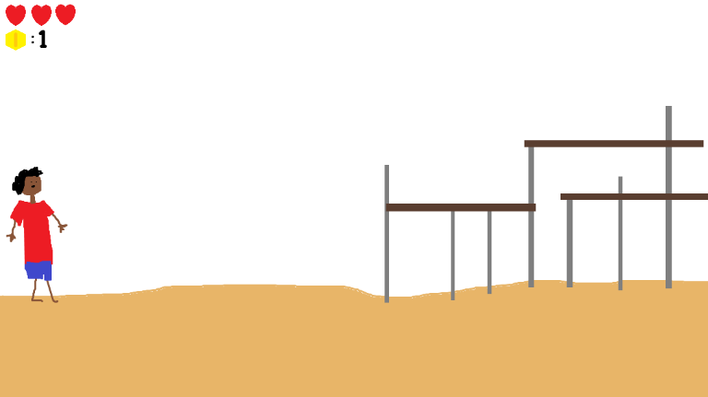

# Perspectives

The perspective for the shanty town platformer will be a 2D side scroller as I believe this is the best perspective for platformer game as proven by other titles such as Celeste and the Mario series. I chose this perspective as it is the easiest and most supported perspective in the game engine I will be using Construct 2.

# FMV

I have thought of many cuts scenes for the platformer game as it will be a heavily story driven game. Story based games need cut scenes to provide the player with information crucial to the story in a short space of time. The first cut scene idea for the game will introduce the player to the main character getting separated from his parents. An interactive cutscene idea for the game could be that the player is confronted by the head guard who tries to grab him and you have to press a series of buttons to be able to escape. The last cutscene idea for the game could be when the boy is reunited with his parents.

One cut scene I definitely want for my game shows how the protagonist gets put into a holding cell in prison which is where the game then starts from as the player has to find a way to escape from the cell. I made a storyboard for this cut scene I will use my storyboard as inspiration and animate a video using Aseprite.

# Idea Generation

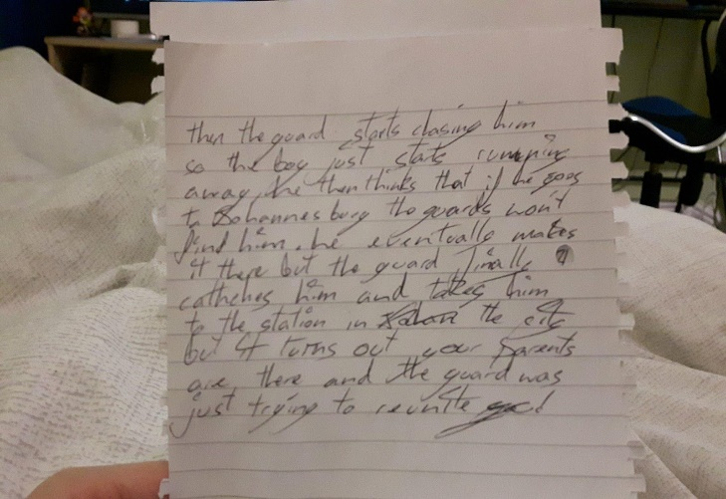 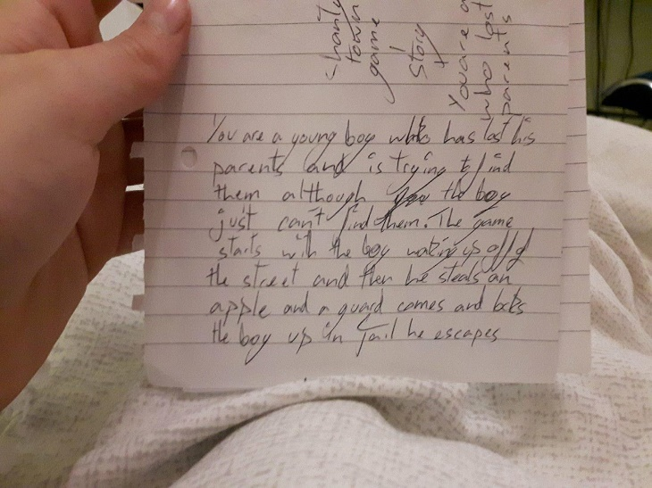

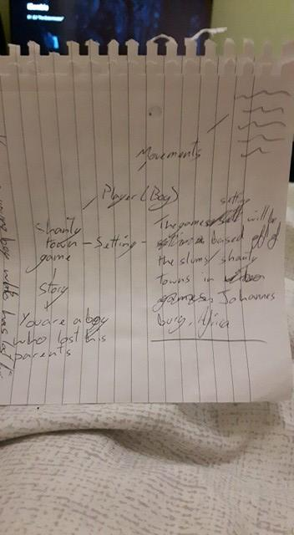

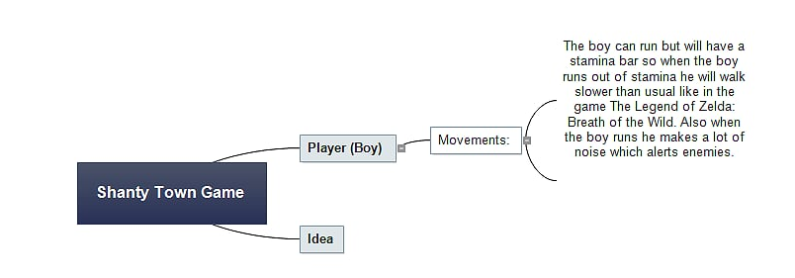

# Mood Boards

The game will be like Little Nightmares where the character is so small compared to the rest of the world and you never feel safe. It will also be like the game Inside where you have to hide from the enemies and make your way past them. The colours in my game will be quite dull reflecting on the main character’s situation however when the player reaches the big city the colours will brighten up as the protagonist is getting closer to finding his family. As you can see I took a lot of inspiration from my mood board especially with the guard. My mood board helped me plan my assets out, so I had a clear vision throughout the initial designing process.

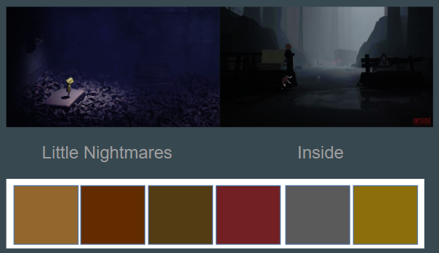

[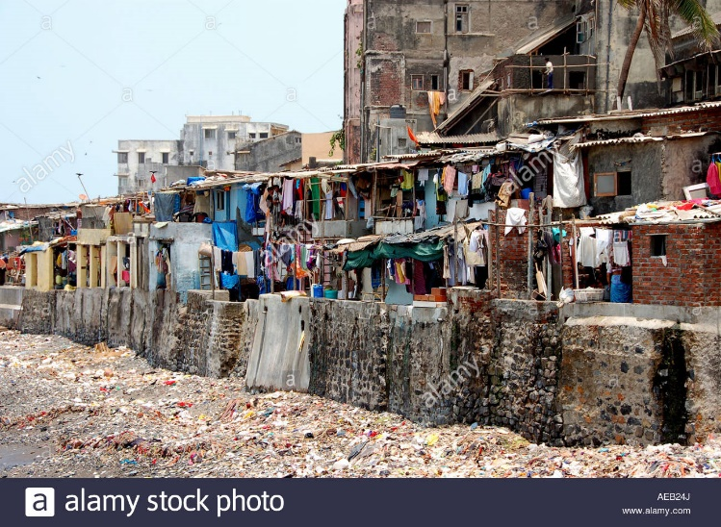](http://www.alamy.com/stock-photo-shanty-town-in-mumbai-or-bombay-viewed-from-a-taxiing-aircraft-at-78006577.html)[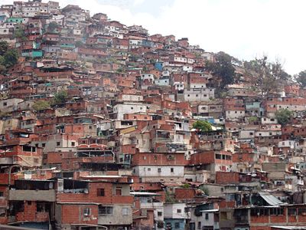](https://propertydrum.briefyourmarket.com/Article.aspx?id=558)

[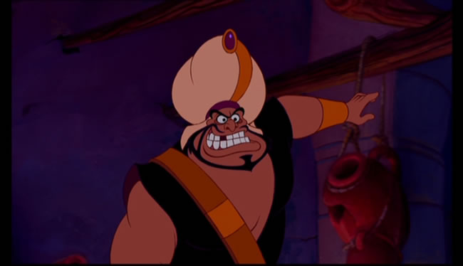](http://aladdin.wikia.com/wiki/Razoul)

# Story Board

I have thought of many cuts scenes for the platformer game as it will be a heavily story driven game. Story based games need cut scenes to provide the player with information crucial to the story in a short space of time. The first cut scene idea for the game will introduce the player to the main character getting separated from his parents. An interactive cut scene idea for the game could be that the player is confronted by the head guard who tries to grab him and you have to press a series of buttons to be able to escape. The last cut scene idea for the game could be when the boy is reunited with his parents.

One cut scene I definitely want for my game shows how the protagonist gets put into a holding cell in prison which is where the game then starts from as the player has to find a way to escape from the cell. I made a storyboard for this cut scene I will use my storyboard as inspiration and animate a video using Aseprite.

|  |  |
| --- | --- |
| Scene 1 | Scene 2 |
|  |  |
| Description: A young boy (the player) wakes up from sleeping on the dirty street floor. | Description: He walks around (while he player enjoys the scenery/view) and his stomach starts to rumble. |
| Scene 3 | Scene 4 |
|  |  |
| Description: The boy finds a stall selling bread but realises he has no money to pay, but his stomach continues to growl and roar. | Description: He decides to grab the bread and run but as he lays his finger on the bread the shopkeeper grabs his arm and says “Boy! Do you know what we do to thieves!” as he proceeds to pull out a big butchers knife. |
| Scene 5 | Scene 6 |
|  |  |
| Description: Suddenly a guard shouts stop and walks to the shopkeeper saying “can’t we be civilised? And lock him up?”. | Description: The guard grabs you and throws you in a cell. Then the game starts as you have to escape the cell and run away from home to the big city. |

# Target Devices

I would like my game to be on every current gen device to access a wider audience however I believe it will be best suited to handheld gameplay so out of every console I would prefer it to be on the Nintendo Switch more as the indie game market is really taking off and doing well on that device.

[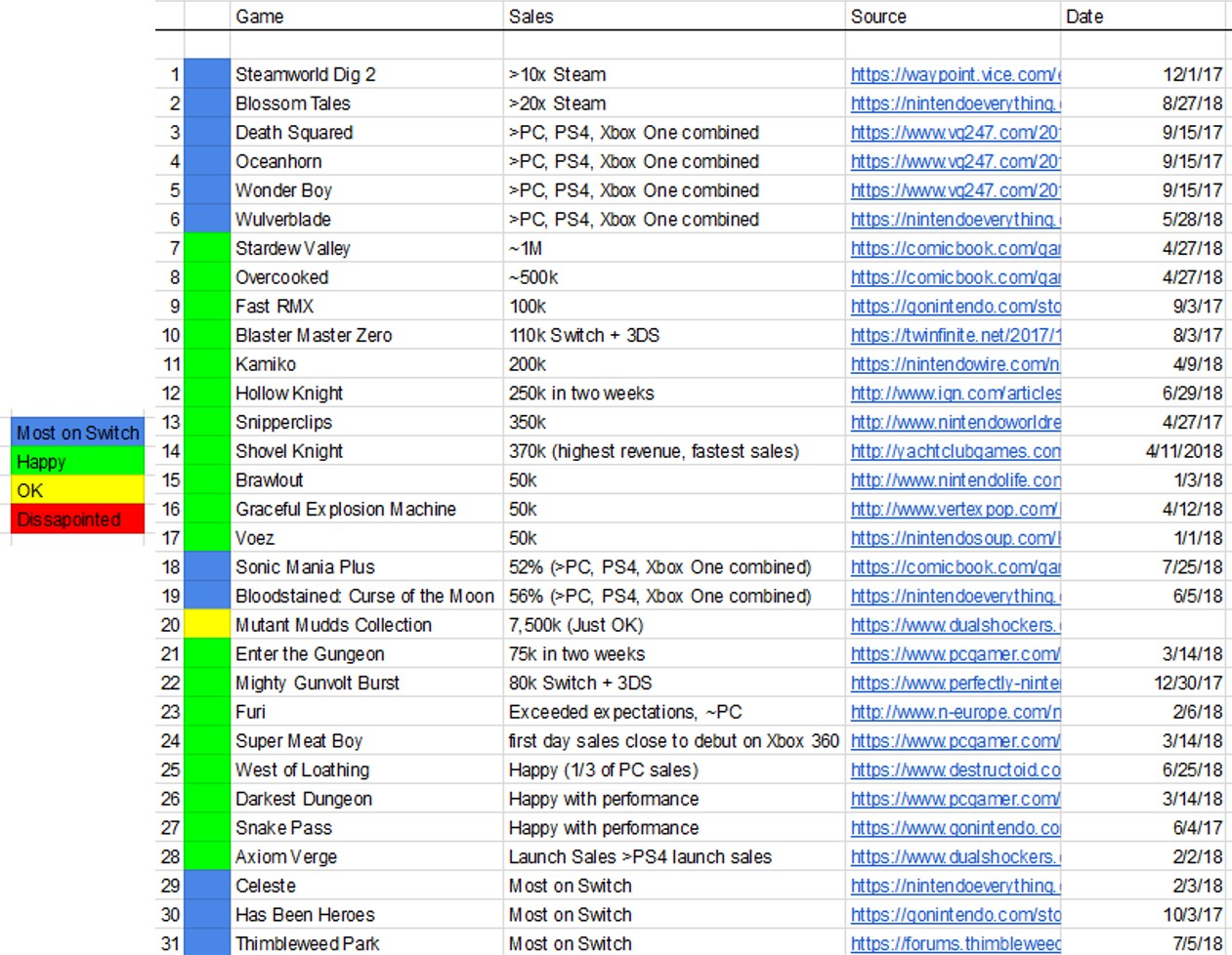](https://www.resetera.com/threads/how-are-indie-games-actually-performing-on-switch-sales-reports-so-far.64916/)

# Game Flow Diagram

This will be the constant objectives the player will have and will achieve throughout each new portion of the game.

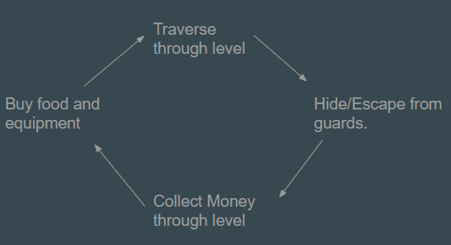

# Risk Assessment & SWOT Analysis

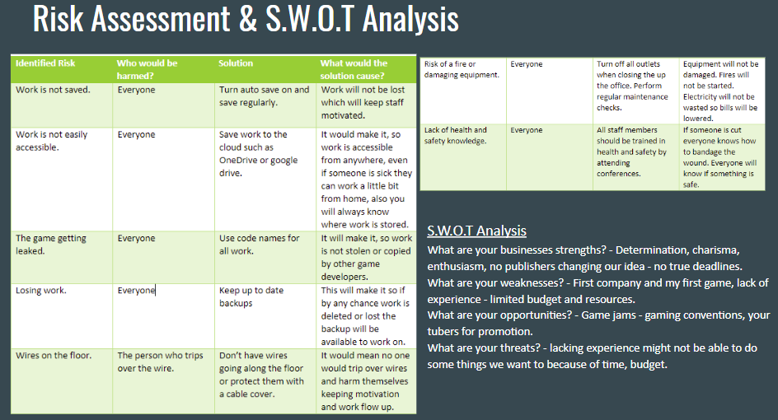

# Resource List & Budget Analysis

Overall my business will need roughly £280,510.93 and here is why.

|  |  |  |  |  |
| --- | --- | --- | --- | --- |
| Item | Price | Amount | Total | Picture/Link |
| Chair | £39.99 | *4 | £156.96 |  |
| Desk | £73.99 | *4 | £295.96 |  |
| Office PC Bundle: Computer, Monitor, Mouse & Keyboard | £479 | *4 | £1,916 |  |
| Photoshop | Per Year: £303.36 | *4: 2 Computers for 2 years. | £1,213.44 |  |
| Aseprite: This is a pixel art creation app. | $14.99 | *4 | $59.96  =  £44.58 | **[https://lh4.googleusercontent.com/b7Jq2b2W3y-HJqifGfGrZIRPA_2ytYoCpUaTgaRkxVNr2B0ZyKHrtHxHUuN2UTbkm6x1sQE-pcN6vrRi4y_mAeBQo12zqx50BQ3j2zEIIIrMEux6gOLsLUZYyMybRJWtgtxQozyf](https://www.aseprite.org/#buy)** |
| Office 365: Word, Excel, PowerPoint, Outlook, OneNote, Publisher and Access. | £79.99 per year | *1 because you can have 5 users at once | £79.99 |  |
| Office in Manchester | £250.00 per month | *12 to get a year the *2 to get 2 years | £6,000 |  |
| I will have a team of 4.  1 Programmer | £30,402 per year | *2 to get 2 years pay | £60,804 |  |
| 1 Artist | £35,000 per year | *2 to get 2 years pay | £70,000 |  |
| 1 Musician | £30,000 per year | *2 to get 2 years pay | £60,000 |  |
| Then myself as another programmer but also a story writer. | £40,000 per year | *2 to get 2 years pay | £80,000 |  |